1. Hammer is **Single Candle Bullish Pattern**.
   1. A **bullish pattern** is where the market either goes up or remain neutral.
2. If we read a book by Steveson about Japanese Candlesticks Charting Techniques, in that book he mentions that a **reversal** is something which tells that the previous trend is either likely to end or completely reverse.   
   **NOTE**: Reversal doesn’t mean the market is going from up to down immediately or vice versa.
3. 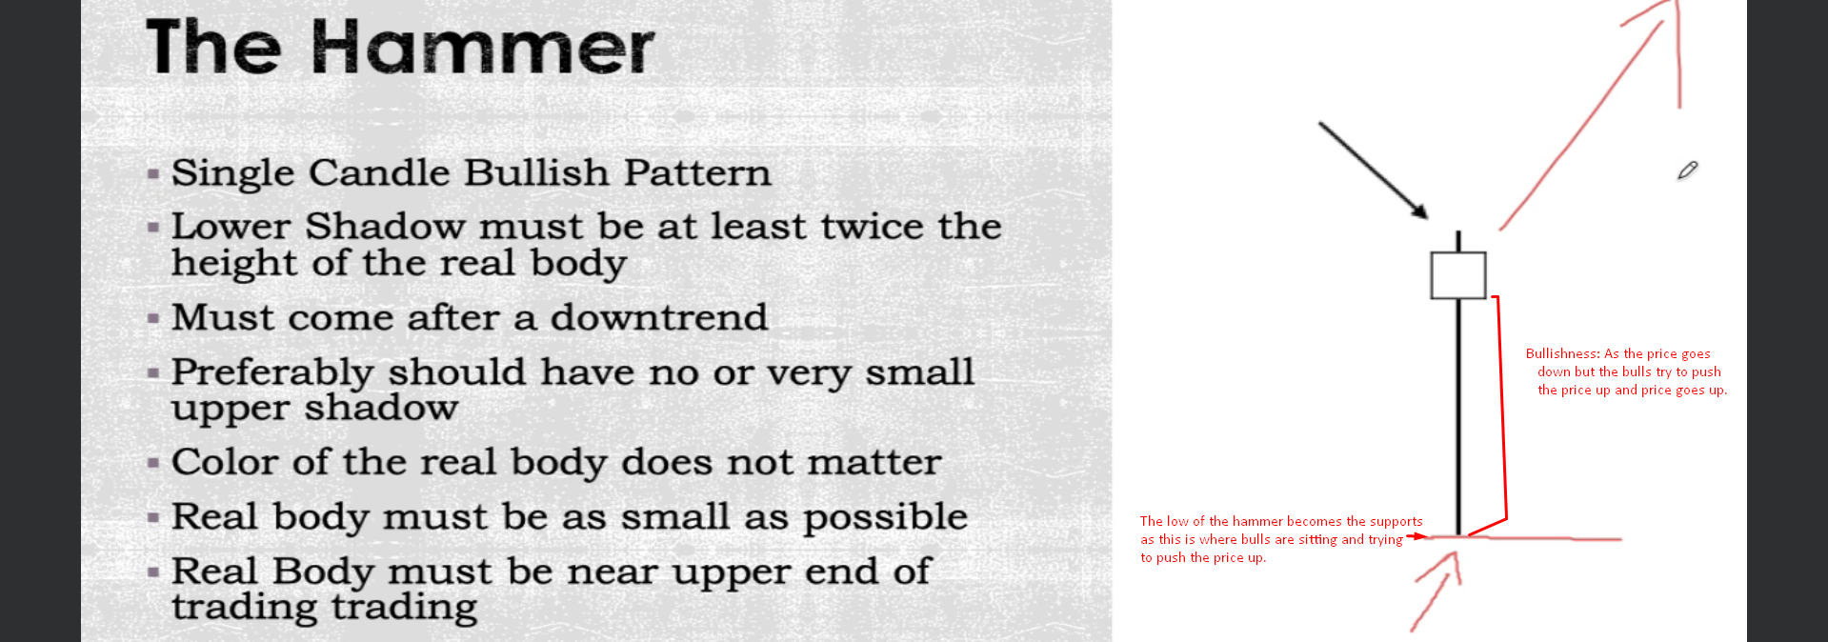
4. A graph with arrows and lines

   Description automatically generated with medium confidence
5. A graph with a red line

   Description automatically generated
6. It is ok if a hammer comes after a short term or long term but much better if comes after long term downtrend.